Ecommerce for Goodwill

by

Pratik Kumar Gaigawale
Parinaya Joshi
Ashwani Kumar

This is a Capstone project submitted to the Marshall University graduate faculty in
partial fulfillment for the degree Master of Science.
Major Subject: Information Systems

Approved:

Instructor of Capstone course

Director of Major Department

Chairman of Graduate Programs

Marshall University
Huntington, West Virginia
May 2019

The material contained within this document is confidential and proprietary property of the Goodwill industries of KYOWVA Area.

Acknowledgements

I would like to thank my advisor Dr. Wook-Sung Yoo, for all his help and guidance. He has guided me through the completion of my masters.

I would also like to thank our client Alissa Stewart and Amy Coleman who made considerable contribution in meeting all the requirements.

Table of Contents
1. INTRODUCTION 6
1.1 Scope 6
1.2 Background 6
1.3 Summary 7
1.4 Road map to the report 7
2. REQUIREMENT ANALYSIS 8
2.1 System Overview 8
2.2 Specific Requirements 9
2.3 Functional Requirements 9
2.4 Non-Functional Requirements 12
3. System Design 13
3.1 Installation of WordPress[1] 13
3.2 Product Flow 15
3.3 Functional Design 16
3.4 Summary 17
4. FUNCTIONAL TESTING 18
4.1 Test Cases and Results 18
4.2 Summary 19
5 SYSTEM INTEGRATION AND VALIDATION 19
5.1 General Assumptions 19
5.2 Summary 19
6. CONCLUSION AND RECOMMENDATIONS 20
7. REFERENCES 21
8. APPENDIX 22
8.1 Screen Snap Shots 22

List of Figures:

Figure 1: Use case diagram for Administrator
Figure 2: Use case diagram for Customer
Figure 3: System level Use case diagram
Figure 4: Activity diagram for Administrator
Figure 5: Activity diagram for Customer

List of Figures:

Table: Test cases for Multichannel Listings web application

1. INTRODUCTION

Multichannel listing is a sales platform, which is used to list number of products on multiple channels. Previously, Ecommerce website is used to upload the products and sell them online.

Scope

A multichannel listing web application is designed to list the number of products on multi sales channel from a single source. One of major objective is to avoid overselling of the products. It helps in reaching out the customers globally which would increase the sales. It has one major user administrator who lists the items on multichannel and generates the reports. The multichannel listing web application was developed using WordPress.

1.2 Background
E-Commerce is now seen as a reality for many businesses and a normal part of a business plan. The immediate benefits, in terms of cost savings, efficiencies and enhanced profitability are clear at every stage in the supply chain. Executives of successful E-commerce companies need to be strategic thinkers focusing on customers, markets, and competitive positioning, as well as on internal operations. Determination of a suitable E-commerce strategy begins with identification of the opportunities and risks. The task of tracking the changing environments, understanding customer groups, requires formulating strategies and planning their implementation.
Many companies approach E-commerce with no clear idea of where they are going, often they view the industry leaders’ accomplishments superficially and try to imitate the front-runners. What they fail to consider is the level of commitment and organizational redefinition that must occur behind the scenes.
The web application helps to provide a listing management system which will list the products and services online to multiple marketplaces, track the orders and manage the shipment and generate the reports. This includes the development of inventory management to keep a track of the stock available in their inventory.
It is suggested to create a web application to post items on multiple channels and generate reports for the same. Upon final review, the company will improve and/or integrate this functionality to the IT infrastructure

1.3 Summary
The current project can operate on any operating system with a working internet connection. The proposed tool is architected to list the products on multiple channels and generate the reports.

1.4 Road map to the report

Section 2: Requirement Analysis: This section discusses various requirements of the project, some constraints and dependencies of the project, the interfaces of the project.
Section 3: Design Procedure: In this section various design issues regarding the project will be discussed. This comprises the interface design.
Section 4: Functional Testing: This section discusses the testing of the tool and whether all the requirements have been met or not.
Section 5: System Integration and validation: System level issues will be discussed.
Section 6: Conclusions and Future recommendations.
Section 7: References to related documents.
Section 8: Appendices

2. REQUIREMENT ANALYSIS

Requirements Analysis is the process of understanding the customer needs and expectations from a proposed system or application. Requirements are a description of how a system should behave or a description of system properties or attributes. It can alternatively be a statement of ‘what’ an application is expected to do.

2.1 System Overview
The objective of the multichannel sales is to list the products on multiple sales channel from a single source without uploading the details of product again and again. Only the administrator of the system can have access to create, modify and delete the listings of products. Generally, Administrator login to the different marketplaces and upload the details of the products like images, stock details, etc. to sell the products. Once the product is sold, he/she has to visit the marketplace again to check number of sales. With the help of this web application, Administrator can list the any number of items to multiple sales channel without visiting them and also check the sales status of the products. Administrator can also end the listing or update the listing from the admin page of the web application.

2.1.1 Problem Position statement
Elements | Description
For | Goodwill Industries
Who | Administrator, Customers
The Product Name | Multichannel listing Web Application
That | A web application that lists any number of products on multiple channels and generates reports.
Unlike | The Current scenario is that they visit different e-commerce website to list the products

2.2 Specific Requirements

2.2.1 User Profiles
The following are the users for this system
2.1.1.1 Administrator
2.1.1.1 Administrator:
Administrator is the person who is owner of this whole system. He has the permissions to provide accounts for customers.
2.1.1.1.1 Can create, modify and delete the listings
2.1.1.1.2 Can generate the reports

2.3 Functional Requirements

Functional specifications are the blueprint for how you want a web project or application to look and work. It details what the finished product will do, how a user will interact with it, and what it will look like. By creating a blueprint of the product first, time and productivity are saved during the development stage because the programmers can program instead of also working out the logic of the user-experience. It will also enable you to manage the expectations of your clients or management, as they will know exactly what to expect.

2.3.1 Use case documentation
2.3.1.1 Use case diagram for administrator
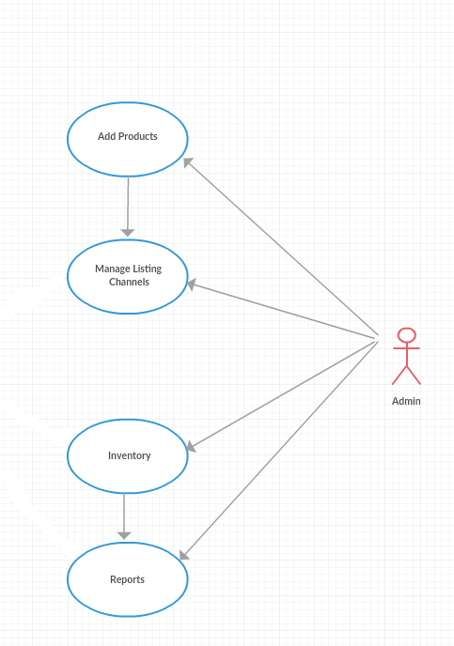

Figure 1: Use case diagram for administrator.

Name: Use case for the administrator.

Description: To create, modify, and delete the listings.

Actors: Administrator

Preconditions: user should have an account on the system.

Main Flow: 1. Administrator will create the accounts for users and assigns the
privileges.
2. Automatic email will be sent upon creation of the user.

2.3.2 User Interfaces
2.3.2.1 Hyperlinks
2.3.2.1.1 Home
2.3.2.1.2 Login
2.3.2.1.3 Report

2.3.2.1.1 Home:
User can come back to the home page of the website and explore the products.
2.3.2.1.2 Login/Registration:
It opens a tab to login for the user or admin and asks the user to enter the username and password of the user and based on the credentials the page will be redirected to the homepage of website
2.3.2.1.3 Report:
Admin can access the report of the products which has been sold by the marketplace or the number of views to the products and how many customers or guests visit the webpage.

2.4 Non-Functional Requirements

This section discusses the constraints under which the deliverables must operate, the environment in which they must operate, and any standards they must conform to, etc.
2.4.1 System Requirements
2.4.1.1 Hardware Requirements
The system requirements for this project are:
        - 512MB RAM is recommended

2.4.1.2 Software Requirements

Language Specification : PHP version 5.6.20

Databases : MySQL version 5.0.15 or greater or any version
of MariaDB

Operating Systems : Windows, Linux

3. System Design
This section discusses the installation of WordPress and plugins for the integration of various marketplaces.
3.1 Installation of WordPress
3.1.1 Installation of Plugins in WordPress

3.1 Installation of WordPress[1]

WordPress is a popular free software for personal publications (blogs). It uses PHP and MySQL as server-side technologies. Its installation/maintenance is quite easy.
• Requirements
To install WordPress on your hosting account, you need:
-80MB free disk space
- one free MySQL database slot. The database will be created by the automatic installation script
• Installation
To install WordPress, please navigate to the WordPress -> Install WordPress section of your hosting Control Panel.
Please fill in the following fields:
Site Title: You need to enter the name of your WordPress site. You choose this name. For example, it can be related to the content of the blog, the name of your company, your domain name, etc.
Subdomain: Choose the subdomain, in which you want WordPress installed.
If you want to install WordPress in a new subdomain, click on the link Create a subdomain, which will take you to the Subdomains section of the Control panel.
Path: If you wish to install WordPress in the main folder of the subdomain you have chosen, you can leave this field empty. If you wish to install in a subfolder, please click the icon and choose an installation folder.
Use WWW: Prefix the address with www.
Use HTTPS: Set the site to use HTTPS instead of HTTP. This is only possible if there is a valid SSL certificate installed for the host.
Username: Enter the username that you want to use for administering your site. You will be able to create additional WordPress users later, through the administrative panel of WordPress.
Password: Enter a password for the above username.
Password Again: Enter the password again.
Е-Mail: Enter the email address of the main user for administration. You will need this email for example to retrieve the password of your WordPress main user for administration (in case it is lost).
Accept license agreement: You need to check the license of WordPress and accept it.

3.1.1 Installation of plugins in WordPress[2]
Once the WordPress is installed, login to the administrator account. Go to the Plugins option available on the left toolbar. Click add new and search the required plugin. Look out the required plugin from the list and click on Install Now button and then activate your plugin.

3.2 Product Flow

The product flow in the system is shown using the system level use case diagram
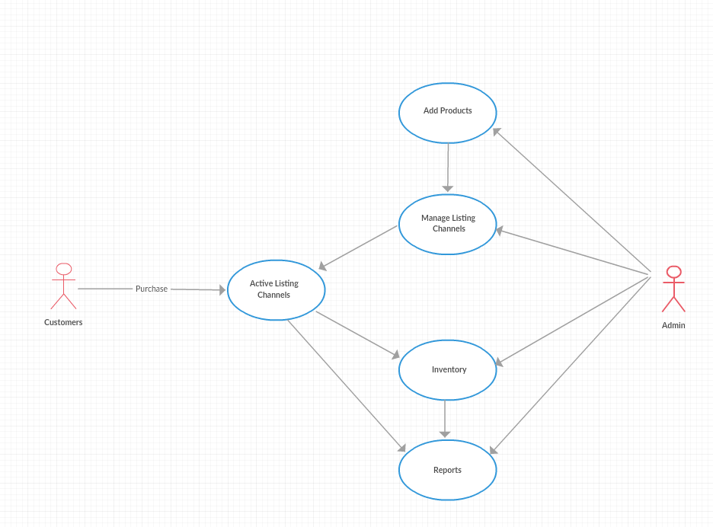
Figure 3: System level Use case diagram

3.3 Functional Design

The functional design description dictates the functionality of the product. Functions discussed in this section directly define the working of the product. The functional design of the product is shown here using the activity diagram.
Activity diagram according to administrator perspective is

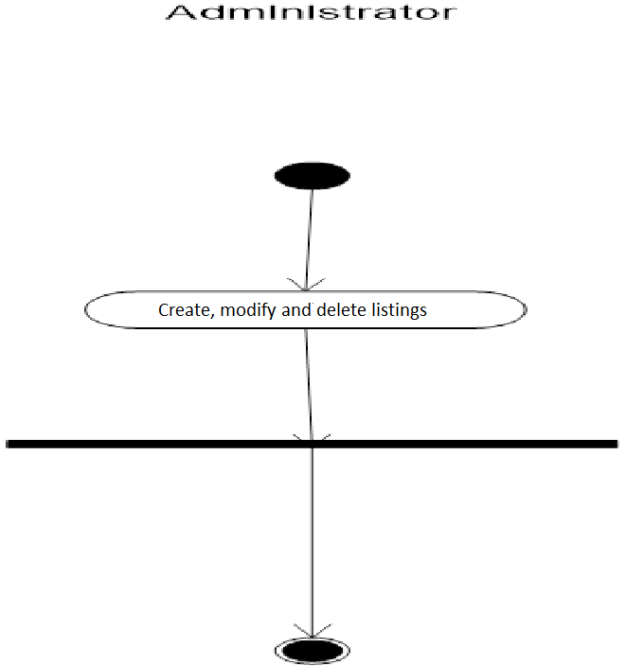
Figure 4: Activity diagram for administrator

Activity from customer’s perspective:

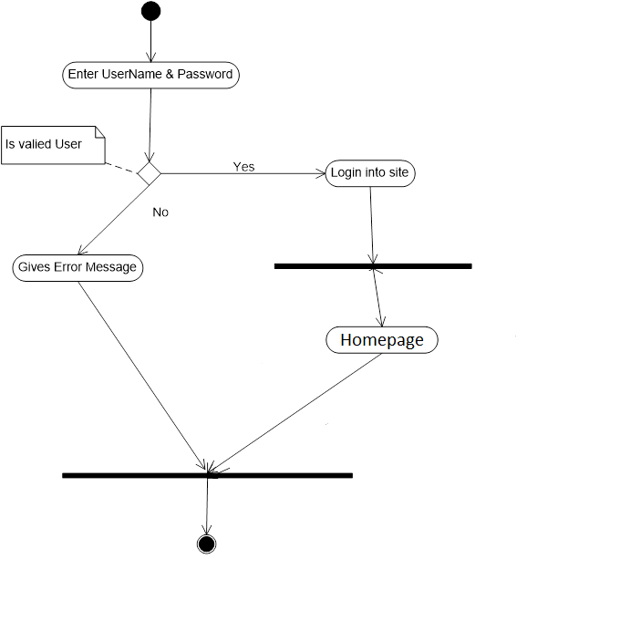
Figure 5: Activity diagram for Customer

Summary

The design is done by sequentially understanding the different user interface with the system. The product flow is discussed by giving the system level use case and the functional design is discussed with sequence diagrams by considering different interfaces.

4. FUNCTIONAL TESTING

Functional testing covers the testing of the key requirements that form the requirements phase and determines whether the mentioned requirements have been met. Testing was done after the tool was developed. The testing included checking every function and testing of the results.

4.1 Test Cases and Results
S.No | Pre-Conditions | Input | Expected Output | Actual Output | Result
1 | Administrator should have an account | Select username and enter password | Administrator can see the home page | Administrator can see the home page | TRUE
2 | Administrator should know the email address of the user | Username, password, email and type of the user | User account will be created based on the privileges given by administrator | User account has been successfully created | TRUE
3 |  | Administrator should select the listing channel where he/she wants to list the product | Product will be successfully listed | Product will be successfully listed | TRUE
4 |  | Administrator should select the particular user | The requested user will be deleted | The requested user will be deleted | TRUE
5 |  | Administrator can access the sales report | Administrator can see the reports | Administrator can see the reports | TRUE
6 | Customer should have an account | Select username and enter password | Customer can see the home page | Customer can see the home page | TRUE
7 |  | Click the Logout Hyperlink | Login page will be shown | Login page has been shown successfully | TRUE
8 | Guest need not to have an account |  | Guest can see the homepage and explore the products | Guest can see the homepage and explore the products | TRUE

Table: Test cases for multichannel listings

4.2 Summary

This section explains how the functional testing is done in this project. Functional testing is done based on the requirements specified. It explains what the preconditions are should have. After entering the valid input, you will see the output mentioned in expected output.

5 SYSTEM INTEGRATION AND VALIDATION

System level testing is necessary for validating the system integration process. The product was tested and can be accessed from any computer having internet connection.

5.1 General Assumptions

5.1.1 In this project we have assumed that the user has a computer and has access to
internet connection
5.1.2 The admin and user are assumed to have a browser of internet explorer version.
5.1.3 The admin and user are assumed to have basic knowledge in operating website
5.1.4 The WordPress must be installed on the server.

5.2 Summary

Taking the assumptions into consideration and other constraints into account, the system has been successfully validated and tested.

6. CONCLUSION AND RECOMMENDATIONS

The current project was successfully done by meeting all the requirements of the stakeholder which were tested in the functional testing phase.
Requirements elicitation and documentation is the key phase for a project. Testing the application with the key requirements is the best way to test the project which will help to see whether all the requirements specified by the stakeholder are met. Future recommendations are automatically closing the user submissions when the formal technical team meeting started using the system’s time.

7. REFERENCES
[1] K, K. (2019, January 15). How to Install a WordPress Plugin – Beginner’s Guide for 2019. Retrieved from https://themeisle.com/blog/how-to-install-a-wordpress-plugin/

[2] INSTALLING WORDPRESS. (n.d.). Retrieved from https://tickets.suresupport.com/faq/article-1862/en/installing_wordpress

8. APPENDIX

8.1 Screen Snap Shots

8.1.1 Login Page

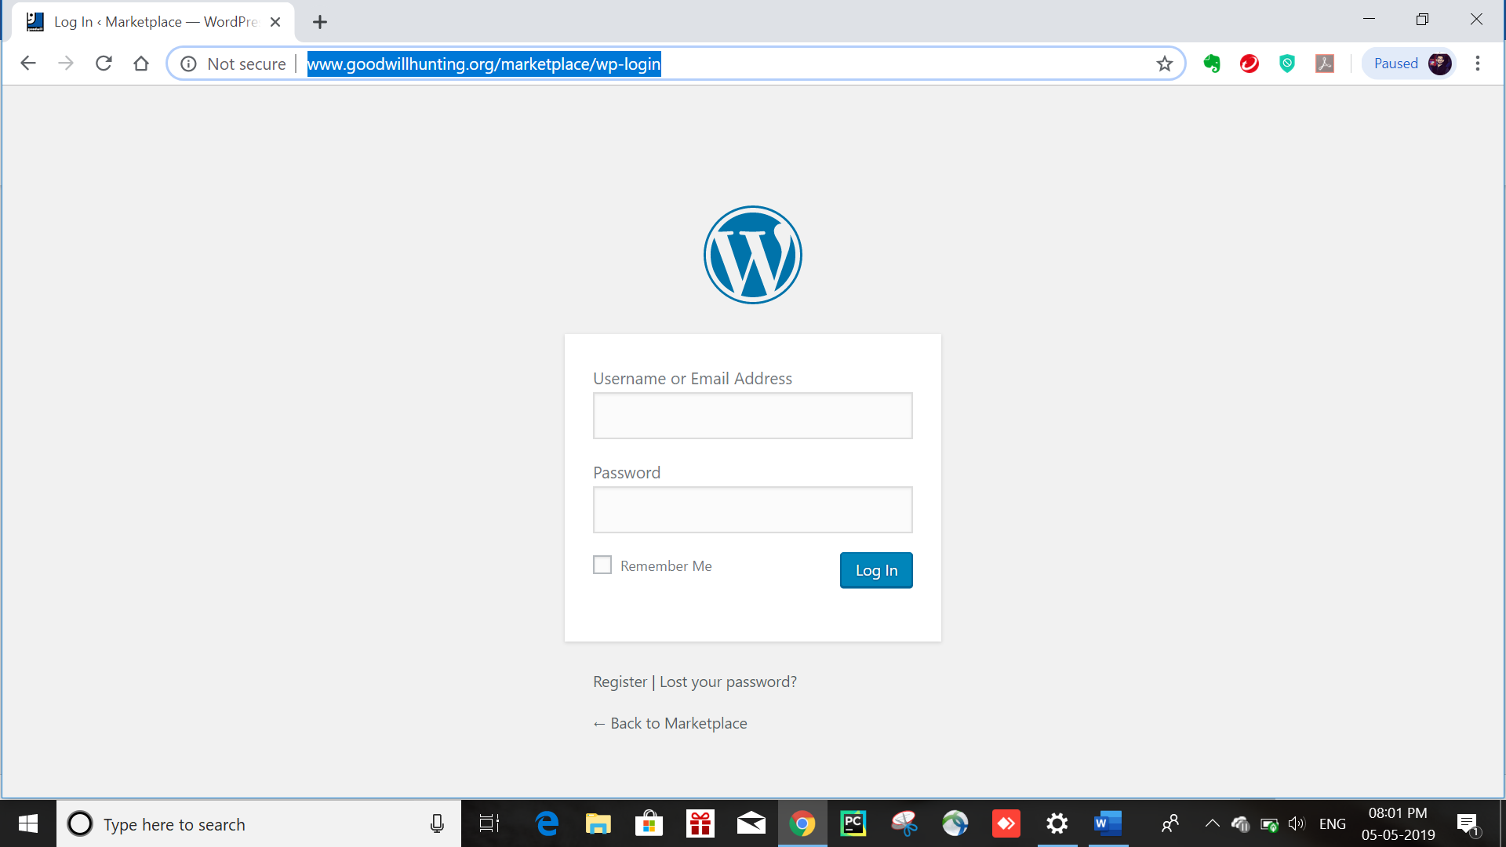

8.1.2 New Product listing Creation

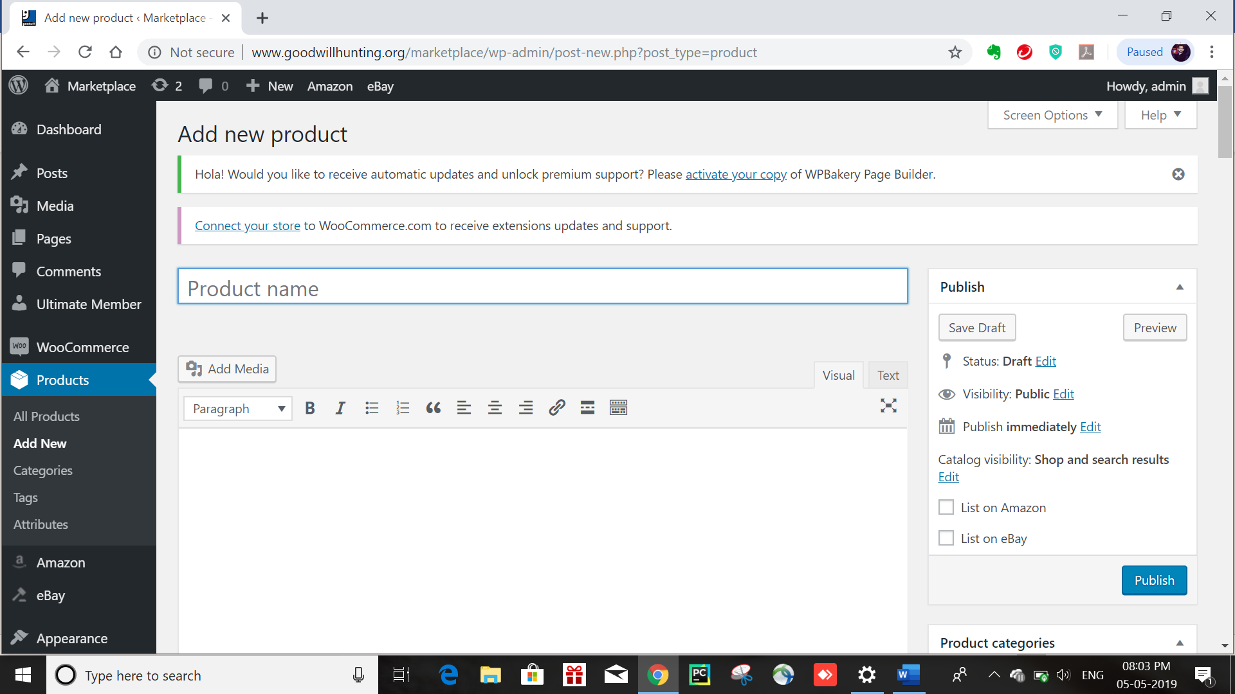

8.1.3 Enter Amazon Details
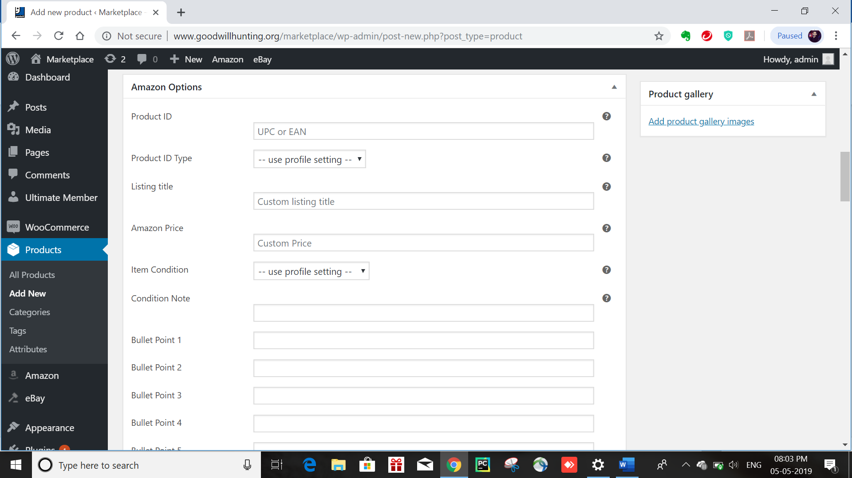

8.1.4 Enter eBay Details
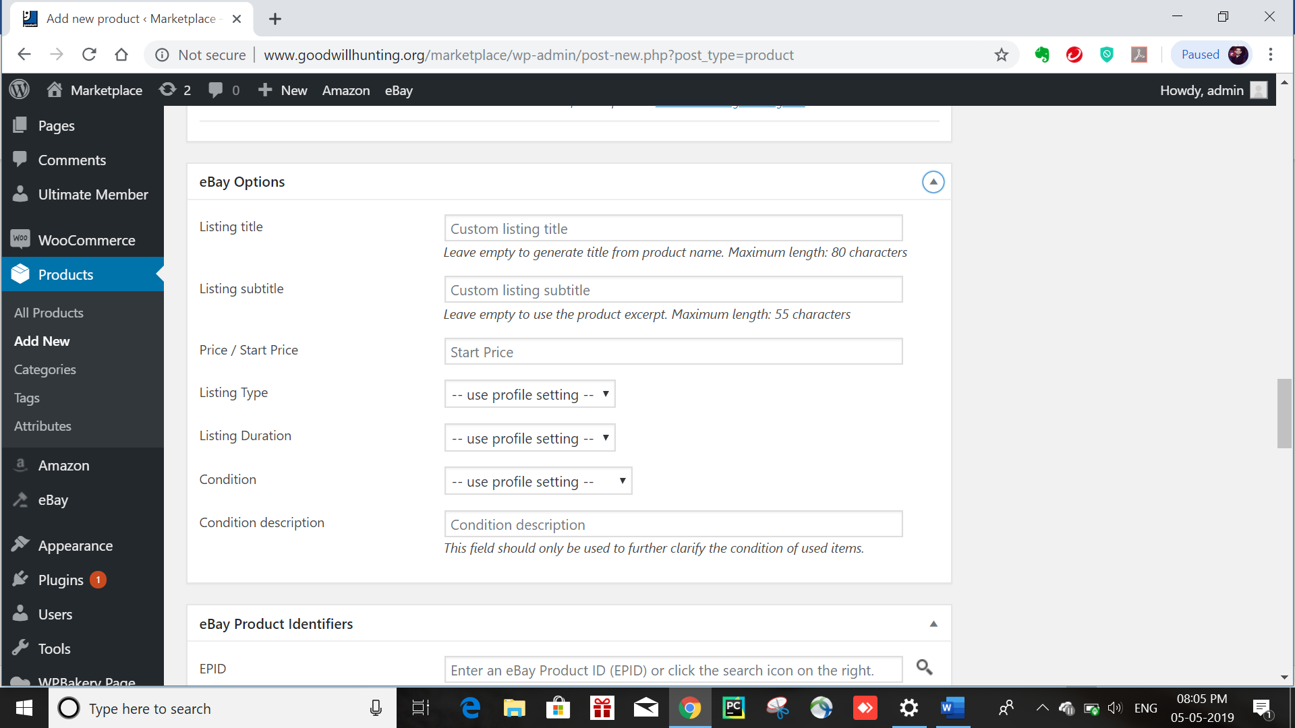

8.1.5 Amazon Listings
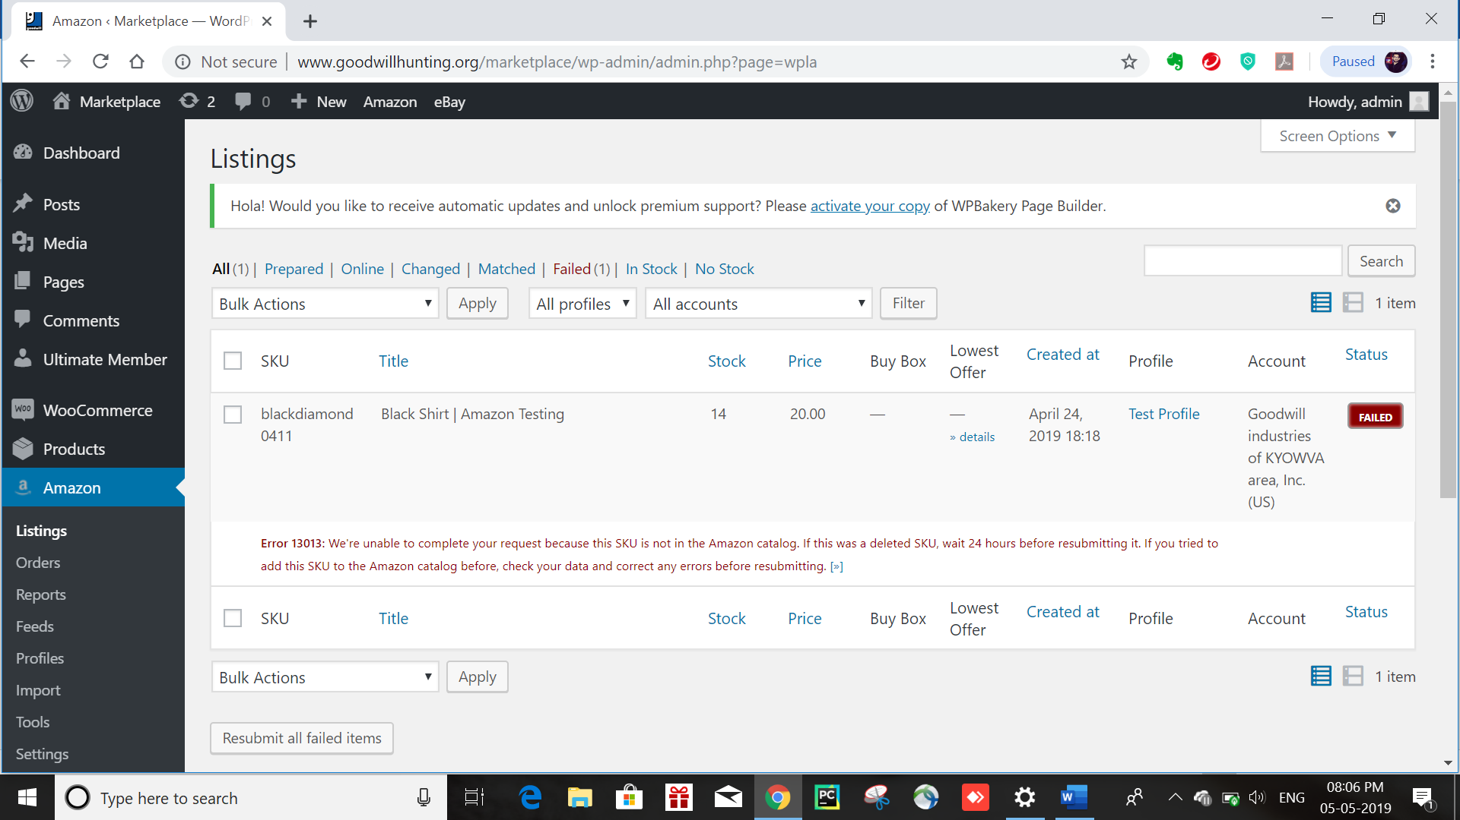

8.1.6 eBay Listings
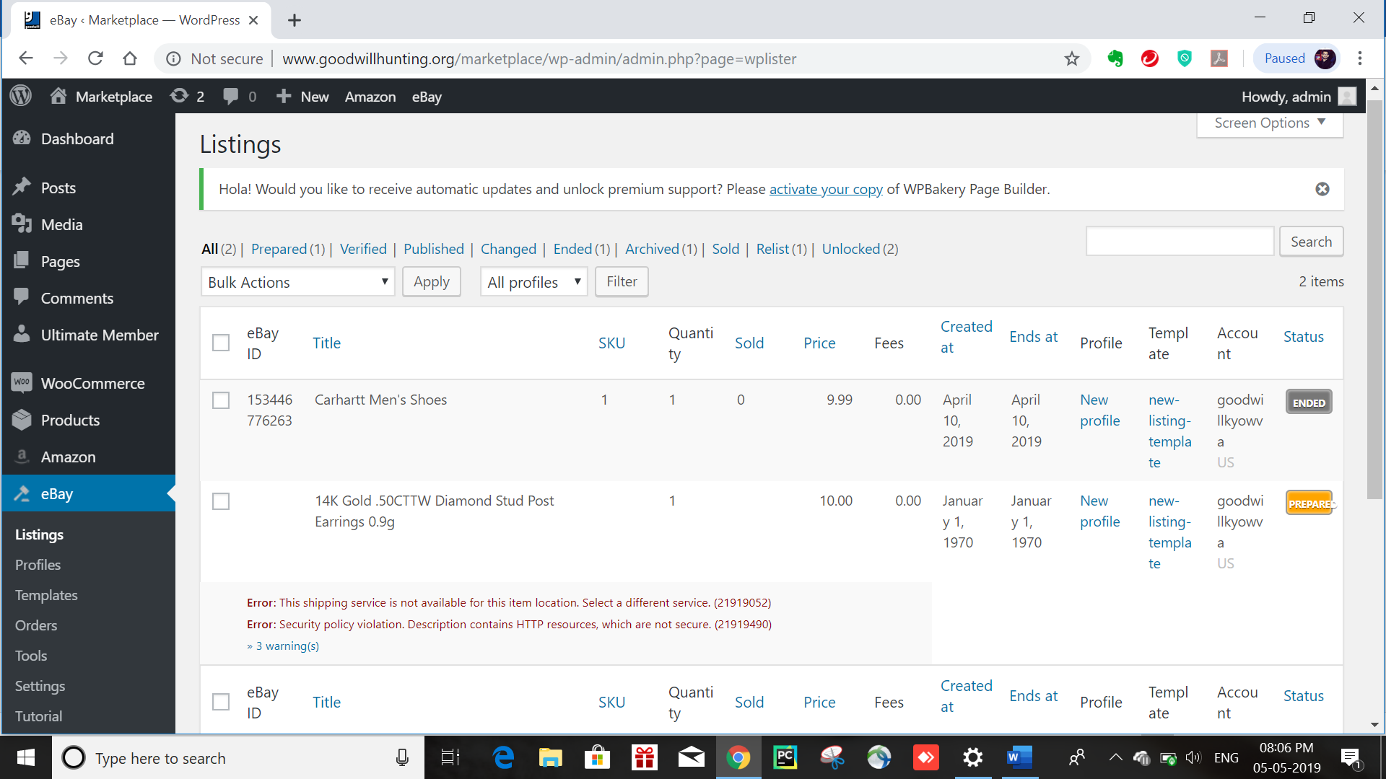

8.1.7 Reports
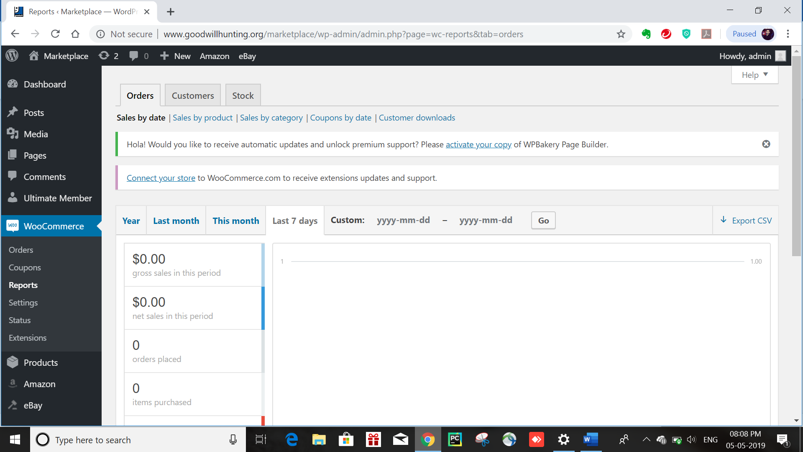

8.1.8 Marketplace
